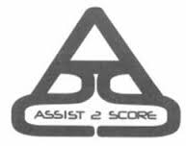
Assist 2 Score, LLC
New Hire Check List (Independent Contractor)

Signed & Returned Not Applicable
PAYROLL DOCUMENTS (Return no later than 1st week of work.)

1. Independent Contractor Agreement

2. Direct Deposit Authorization
Complete and return with a voided check or bank letter.
3. Form W9
Complete top portion only.

POLICY DOCUMENTS (Read, sign and return acknowledgement sheet. To be used as reference.)

1. Data Confidentiality Acknowledgement

2. Standard Code of Conduct Acknowledgement

3. Conflict of Interest Policy

4. Nondisclosure agreement

5. Noncompete agreement

If you have any questions, please contact LaShawn Maloy, Insert Position Title
Telephone: Insert Phone Number Email: Insert Email Address

